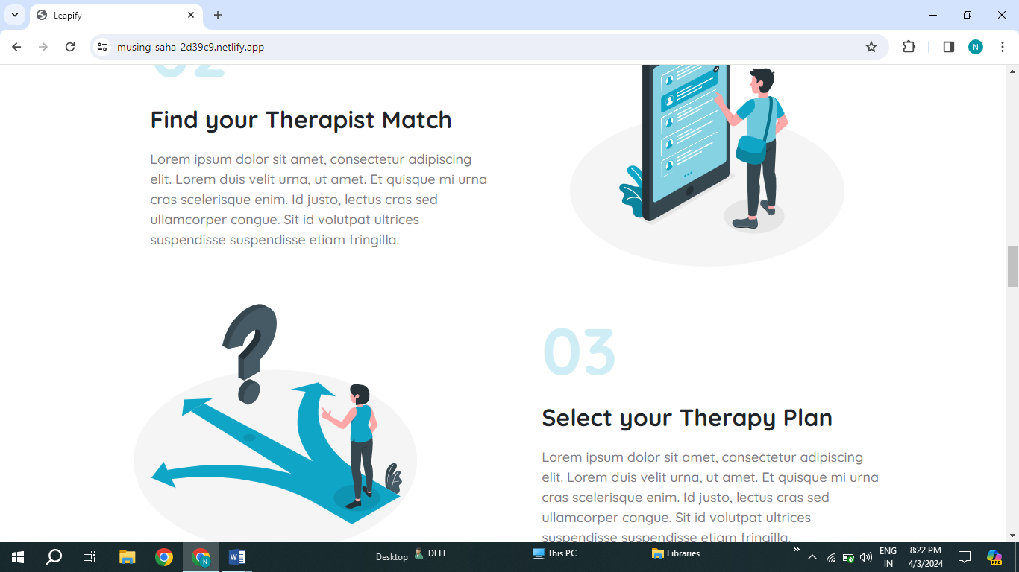

1.Y should be capital from” your” spelling.

2.It should be understandable English Language